Logan Fields

Carolyn Garvin

Charles Brooks

CSCI-C200-13886

Fall 2017

**Team 1 Final Project Write-Up**

**Introduction:**

Breakout is a classic game that involves using a paddle and a ball to break through a wall and reach the top. The game utilizes player controls to bounce the ball into some bricks, breaking the bricks and creating a path for the ball to be free. This game has been done in many ways and with many different components. We took this classic game and gave it a little spin with some Christmas cheer!

**Team**

Logan:

The mastermind behind most concepts. Logan remained a vital asset to the

group. Logan has more knowledge and experience with coding, so he was able

to help Carolyn and Charles throughout this project. Logan was who the team went to with any questions and was able to assist tremendously along the way. Logan was the best at debugging and finding better solutions to the code in order to best create the game.

Carolyn: The graphic designer of the group for sure. Carolyn was able to retrieve and

edit images to best suit them for our game. She designed the theme and was

able to create the different patterns, symbols, and other images that were necessary to our groups’ game. Although these were her main roles, she was also clever at creating code in order to build the different aspects of the menu screen and other components that assisted the game as a whole. Her willingness to take on new challenges really assisted throughout the entire project.

Charles: The team member with the least experience. Charles was present at all

meetings and came through on his parts, but he was assigned less roles than the

other members because he had to do much more research. Charles had never

worked with, or had any desire to work with coding before this class, so he was

doing his best throughout the entire assignment. Charles was able to code the

smaller tasks and come up with different strategies such as scoring and other

concepts. Charles went to the other team members for help, but was able to hold

his own throughout the project.

Throughout this project, our group met as often as we could. This was not always the easiest task, but we made sure we made time to meet outside of the class. We met several times a week and when we were unable to meet, we used a video chat to communicate through our coding. We had a group text that allowed us to communicate with one another and ask questions to our group mates with ease. There was a special group dynamic associated with this project that allowed for as much collaboration and working together as possible.

Going off of the communication utilized, we did our best to split up the group work on the assignments. We would meet several times and at the end every person would have specific tasks to work on and complete before we met again. This would allow us to attempt at making all of the work fairly distributed. However, That being said, we split all of the necessary components and worked on our own parts. We assigned one person to be in charge of each component. We all worked together to create the components, but having one person in charge of each portion allowed for us to deliberate fairly and justly. A list of each component and who was in charge for each portion can be found in our documentation file.

**Features Implemented:**

Generally, this game consists of a user moving a paddle around to hit a ball and break through the wall of bricks covering the top. The goal of the game is to create a path and hit the top of the screen. The user wants to complete this task in as little time as possible, while breaking as few bricks as possible. Therefore, there are a lot of portions to creating this game. Here they are:

* Game screen and its dimensions
* Wall of bricks
  + Detect when hit and make disappear when done
  + Detect when hit twice for multi-hit bricks and unbreakable bricks
* Paddle
  + Make movable by user
  + React to colliding with ball
* How the ball bounces
  + Angles the ball moves when it interacts with other objects
* Detect when the user wins and loses a level
  + Screen to indicate the user has passed a level
    - Take the user to the next level
  + Screen to indicate the user has failed a level
    - Take away a life from the user’s lives
* Main menu screen
  + Option to start a game
  + Instructions on how to play the game
  + Option to see high scores list
* Pause screen
  + Access to pause the game for a user
  + Give the user the ability to resume the game
  + Give the user the ability to navigate back to the main menu
  + Give the user the ability to restart a level
  + Give the user the ability to quit a game
* Scoring
  + Certain amount of points dependent on time, number of bricks broken, and the level
    - Certain number of points for having score under a certain time
    - Certain number of points for breaking specific number of bricks
    - The points increase in value throughout the levels
  + Allow the game to decipher when a user breaks a high score
    - Give the user the ability to enter their initials to record their score
    - Record the 10 highest scores in a high score list on the main menu

**Beyond the Standard Features:**

* Power-ups gotten from certain bricks
  + Larger paddle for 10 seconds
  + Extra life (maximum 5 lives total)
* Sounds through .wav files
  + Sound when the ball hits the paddle
  + Sound when the ball hits the walls
  + Sound when a brick is broken
  + Sound when a brick is cracked
  + Sound when an unbreakable brick is hit
  + Sound when the ball reaches the top
  + Sound when the ball hits the bottom under the paddle
* Changing of multi-hit bricks once hit
  + Once a double hit brick is hit, change to shattered brick image
  + Once a triple is hit once, change to cracked brick, then shattered once hit again

**Software Development Process:**

There were many portions from this project that acted as learning experiences. We learned how much research goes into creating different projects and program. Along with this, we learned how much information is truly out there. We were able to find solutions to almost every problem we had from different resources on the internet. There is a lot out there to assist with different issues. As well, we all developed a greater understanding for pygames and how pygame can be utilized to create interesting games and other graphic implementations. These educational moments will help us in our future classes. There was a lot of learning that came out of this project that will assist us all with our future endeavors in computer science.

Working as a team was a tremendous help for us. We were able to bounce ideas off of one another and have each other to rely on when we got stuck. It especially helped having partners that were more comfortable with the software. That aided the process tremendously. We were able to meet multiple times throughout the entirety of the project and break down all of the portions. We had some struggle finding times to meet because of our busy schedules, but nothing too unmanageable. We were also able to video chat to assist the process. Overall, working in a group made this entire process easier and more feasible.

Finally, there are a couple aspects of this project that could be changed. Our number one issue with the project was the amount of time we were given to complete it. We think that this was a sufficient amount of time, had we no other classes. But since we all had other classes and tons of work to do in those, it made it difficult to complete all of the tasks in a timely manner. That was especially true for those in our group that had to do a lot of research to complete their portions. It just seemed rushed, so we think another week or two would have been efficient. Other than that, we did not have any real complaints. The milestones seemed fairly divided up and the teacher and other instructors made themselves available to help.

**Future Work:**

If given more time to work on this, we would like to implement more power-up tokens for the user. We discussed the possibility of adding lasers to the paddle that allows you to break bricks and other components similar to this. We would figure out the speed issues presented on Mac computers (it runs slower on them for some reason). We would also add songs to the background so the user can listen to some sound effects while playing the game in addition to giving the user the option to turn off sounds. We would also work out any little kinks that are present in our current code and game display, making it smoother and less ‘twitchy’.

**Images:**

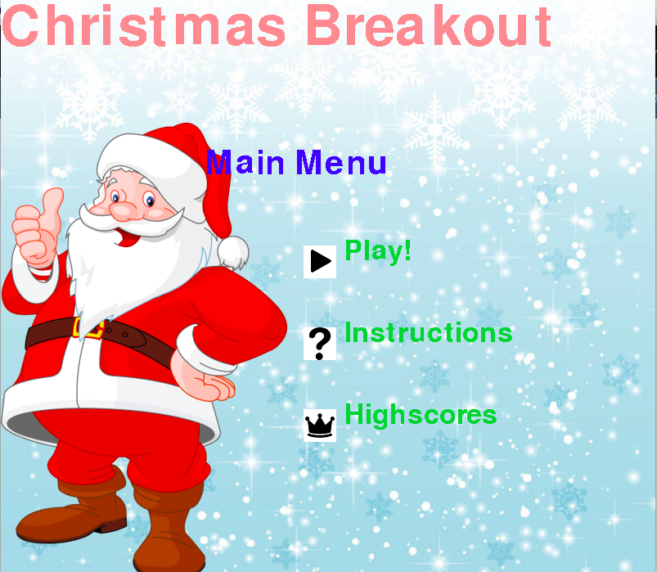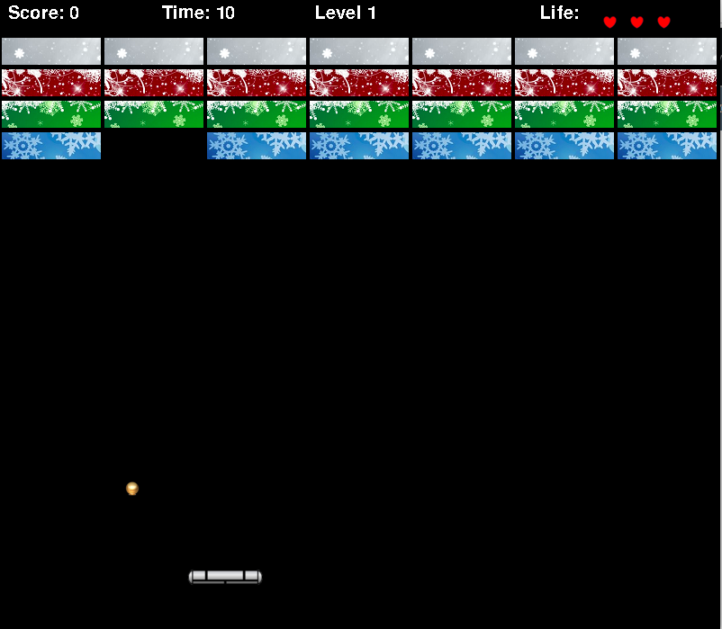

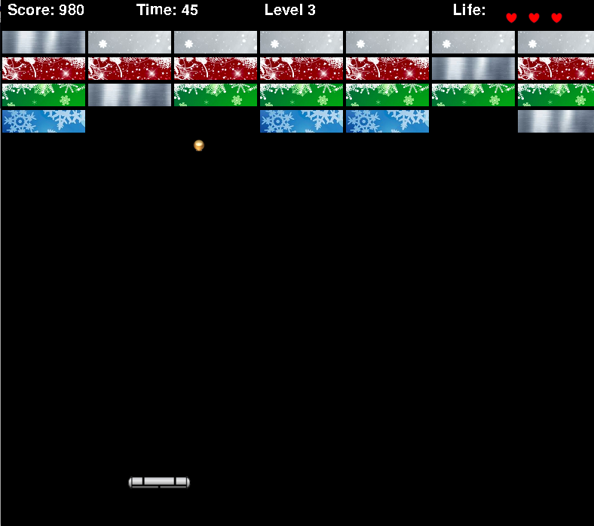

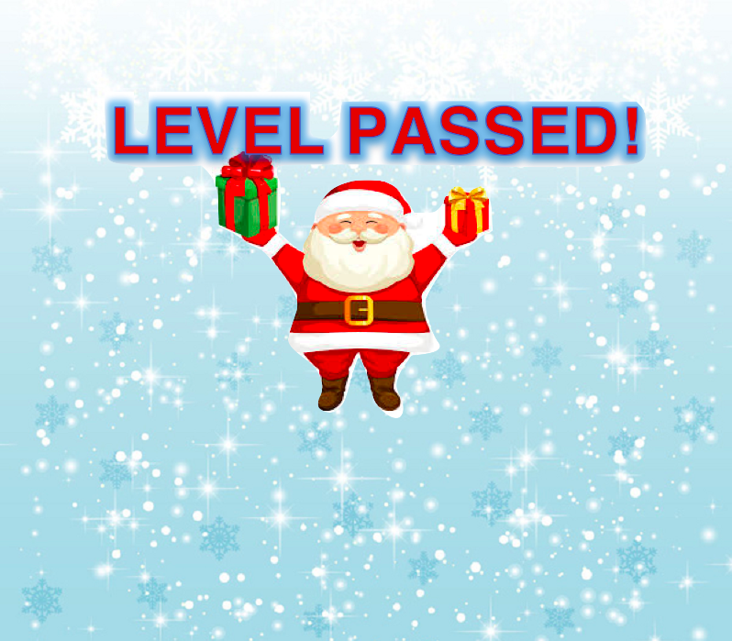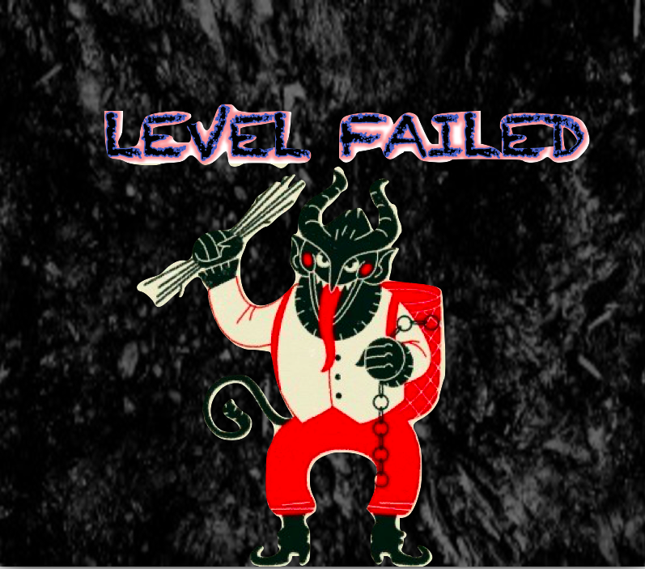

**Code Listing:**

gameDisplay.py (main file)

Wall.py

Paddle.py

Brick.py

The rest of the modules are unimportant because we used them for mainly debugging and testing before moving the code into gameDisplay.

|  |  |  |
| --- | --- | --- |
| **Component:** | **Team Member in Charge:** | **Date Completed:** |
| Display brick layer on screen top w/ each brick as an object | Carolyn | 11/20 |
| Player paddle at bottom of screen | Charles | 11/20 |
| Ball placed randomly between bricks & paddle w/ random initial direction | Logan | 11/23 |
| Detection of ball hitting sides & appropriate change in direction | Logan | 11/20 |
| Detection of ball hitting ceiling & indic. of level completed | Logan/Carolyn | 11/25 |
| Detection of ball hitting floor & indication of level failed | Logan | 11/23 |
| Player ability to control paddle via keyboard or mouse interface | Charles | 11/20 |
| Change in angle of reflection of ball depending on where it hits player paddle | Logan | 11/23 |
| Destruction of a brick when hit by ball | Logan | 11/29 |
| Add level progressions → at least 5 levels | Logan | 12/5 |
| Images for all menu functions | Carolyn | 12/2 |
| Design and implement a score function that adheres to the game objective | Charles | 12/6 |
| Add persistence for the top 10 high-scores/users in old-arcade style fashion | Charles | 12/7 |
| Add a main menu game screen | Carolyn | 12/2 |
| Add a game screen for viewing the high-scores | Charles | 12/7 |
| Add a game screen for viewing game-play instructions | Carolyn/Charles | 12/2 |
| Add the score, number of lives, and a timer to the display | Logan | 12/6 |
| Adding functions to lose a life | Logan | 12/5 |
| When a person loses all lives, they would be directed to enter their initials for high scores or lose | Logan | 12/6 |
| Feature 1: Powerups | Carolyn/Logan | 12/15 |
| Feature 2: Sound | Charles | 12/12 |
| Feature 3: Brick Cracking | Carolyn | 12/11 |

We also kept a log of when each person logged on and for approximately how long. This also included group meetings and skype sessions to keep record of how long the project was worked on and by whom:

Logan 11/18 11:30am-11:50am

Team meeting 11/19 3:45pm-4:10pm

Logan 11/19 4:30pm-6:30pm, 7:40pm-8:10pm, 10:45pm-11:20pm

Logan & Carolyn 11/19 11:45pm-12:05am

Carolyn 11/20 12:05am-1:30am

Charles 11/20 11:50 am -12:05 pm

Charles & Logan 11/20 2:30pm-3:00pm

Charles 11/20 9:15pm- 9:35pm

Charles 11/22 12:00am-12:30 pm

Logan 11/23 2:30pm-4:40pm

Logan 11/27 11:15am-11:40am

Carolyn 11/28 3:45-5:00

Charles 11/28 3:45-5:30

Logan 11/29 12:00pm-1:30pm, 3:00pm-4:00pm

Team meeting 11/30 2:45pm-3:20pm

Team meeting 12/1 12:30pm-2:00pm

Logan 12/1 7:20pm-8:30pm, 11:45pm-12:30am

Team meeting 12/2 3:00pm-5:15pm

Logan & Carolyn 12/2 5:15pm-7:00pm

Logan 12/2 11:00pm-1:00am

Logan 12/3 12:45pm-1:45pm, 4:15pm-5:00pm, 7:00pm-8:30pm

Logan 12/4 7:00pm-7:30pm

Logan 12/5 1:45pm-2:20pm, 5:00pm-5:45pm, 11:00pm-11:15pm

Logan & Charles 12/5 3:10pm-3:45pm

Logan 12/6 11:45am-11:55am, 2:20pm-3:25pm, 9:00pm-10:30pm

Team Meeting 12/9 5pm-7pm

Logan 12/9 8:00pm-8:15pm

Charles 12/11 6pm - 7:10pm

Carolyn 12/13 11pm - 4:00am

Logan & Carolyn 12/14 2:30pm-3:30pm

Logan 12/14 11:00pm-2:00am